**MOLTEN CHOCOLATE LAVA CAKE**

**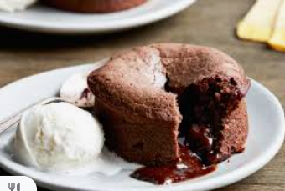***Yield: 7*

1. 1/2 cup butter – cut into pieces
2. 1 Tbsp butter to coat muffin tins
3. 4 ounces semisweet chocolate chips (or ¾ cup)
4. 3 eggs
5. ¼ cup sugar
6. 1 Tbsp flour

Directions:

1. Preheat oven to 450 degrees. (rack in middle)
2. Butter sides and bottom of 7 muffin cups.
3. Melt butter and chocolate chips until smooth in top of double boiler on medium to high (number 8). Or microwave in 15 second increments stirring between each increment. BE CAREFUL NOT TO BURN if using microwave. Set aside to cool for 2 minutes.
4. In a bowl beat eggs and sugar with a whisk until sugar dissolves and very frothy (3 – 5 minutes).
5. Stir egg mixture into chocolate mixture (top of double boiler) until smooth.
6. Add flour and beat until ***just combined***.
7. Fill 7 muffin cups about 1/3 inch from the top – be sure to use all the batter.
8. Bake until batter puffs but center is not set, 7 to 8 minutes. 7 in school ovens.
9. Let stand for 1 minute. To remove from muffin tin carefully run a dinner knife around the outside edge of each muffin cup and loosen the bottom. Use 2 spoons to carefully “lift” the cake out.

Serve with vanilla ice cream and enjoy!